**GIT TECHNIQUES :-**  
 in this document we will see how to   
1) Fork a repository of others and raise a PR (how to get other repository into our repository)

1. Cloning already existing repositories and raising PR  
   3) Updating the files from local environment to already existing repository  
   4) Deleting the files in the local environment and again updating in the remote repository
2. Pulling the changes from remote repo to our local repo using git pull origin   
   6) How to checkout branches in order to get the files which are present in that branch in remote repository  
     
     
   **FORKING REPOSITORY :-**If we want to get the repository of others (a copy) into our repository we can use this method which is called forking repositories.  
   * First in order to fork a repo of others into ours repository we need to get the link of the repository of our friend or the ones whom we want to clone.  
   **<https://github.com/sainavatej/aem-files.git>Note :- Make sure the repository is in public visibility. So that only we can able to clone it.  
     
   \***Now when we redirect to the repository link . we can able to see Fork option as below image. Click on FORK button on the right side of the repo.   
     
     
     
     
     
     
   * As soon as we click on fork button we can see the below option which is Create new fork. Here we can able to select the option which is Copy the main branch only(if you checked this button will get the main branch copy only in your repository). If you want all branches as a copy we should uncheck this option and then click on create a fork.  
   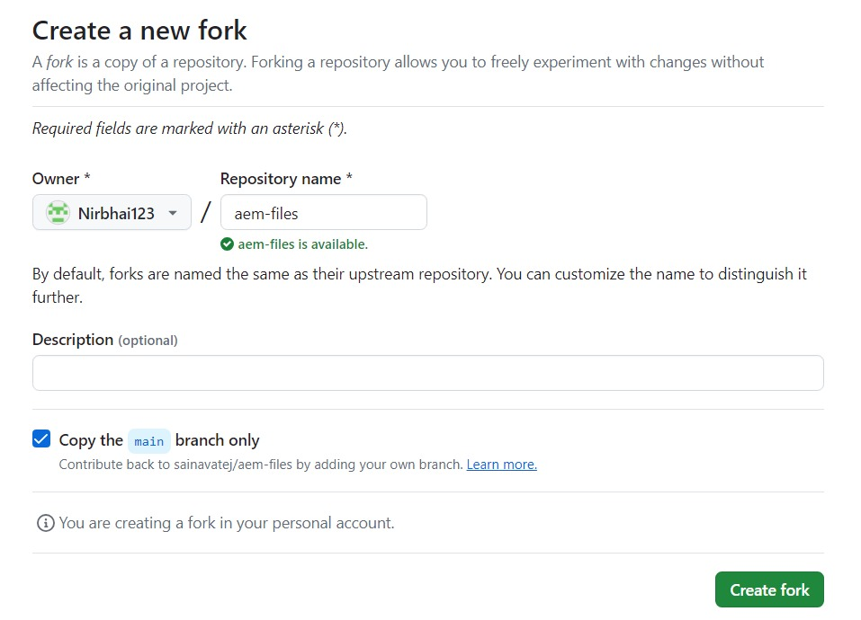

* Now a copy of your friends repo will be created in your repository. As below image  
  
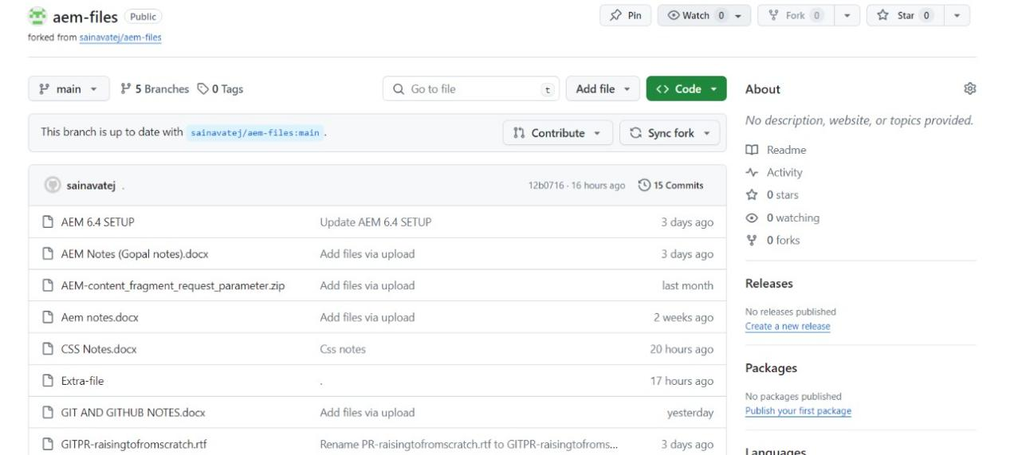  
  
  
* Now we can clone this project into our local environment by using gitbash and u can raise a PR.

*Now you have added the changes,commited and pushed from local to remote now you have to raise pull request from you repository as shown as below. So that only the fork owner can able to see the pull request in his repo.

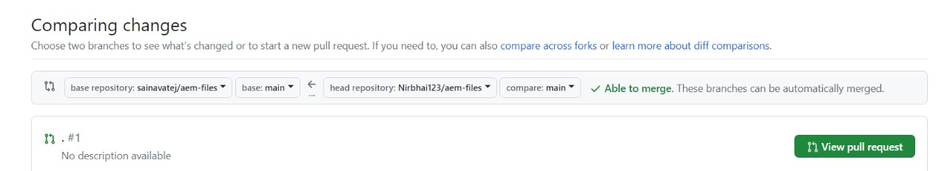

*Now you have raised a PR from your repo but the repository merge access is available only for repo owner because its is your friend repository. So only he can able to check the PR Raised by you and he can only able to merge the changes accordingly. Below is a sample reference image(it is shown in your friend repo)

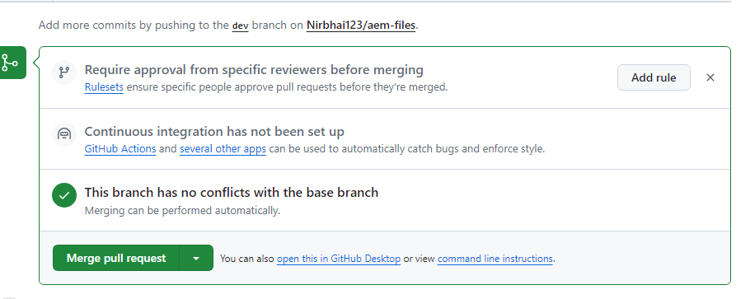

*Now he can able to merge the pull request by checking changes made by you and so that changes will be updated in his repo as well as your repo if he clicks on merge pull request.  
He can also have an option to close the PR as shown as below.  
